Jared Parkinson

Mod 4

OSU CS162

**Non recursive vs the Recursive Fib numbers:**

Going into this I assumed that the recursive functions were going to end up being longer of course. I didn’t have a time frame to put my expectations to, but I did think it would continue to get a larger gap between the two as time went on.

Below we can see that the Non Recursive time barely jumped up until #22, then it went back down. In contrast, the Recursive started to jump up quite a bit around #27 and steadily rose. **I would not recommend anything past N = 48** for testing purposes. In Flip, even though I am using a double it doesn’t seem to post the .001 time for Non Recursive. That being said, flip was MUCH faster than my own machine using Visual Studio. I have included visual studio screenshots to show you the output for the Non Recursive.

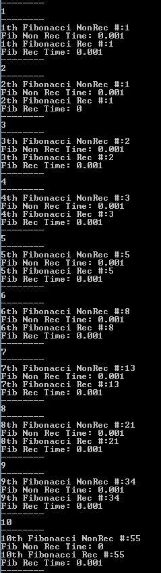 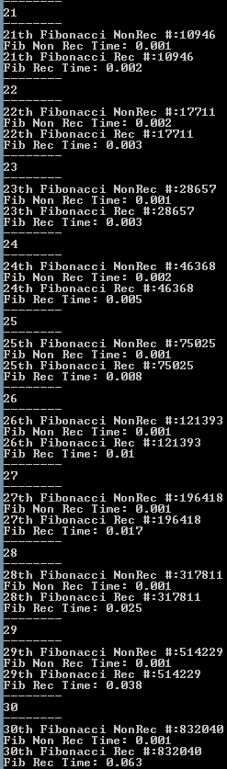 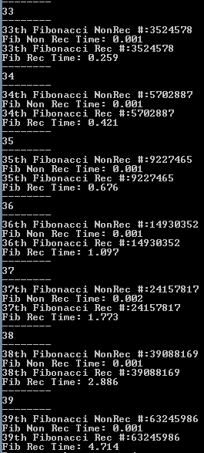

By 38 and 39 it starts to explode and almost double. If you accidentally choose N much higher than 50 I would definitely hit Ctrl+Z to suspend the program.

**Factorials**

For factorials, you will want to use something between **500,000,000 and 1,000,000,000** to see any form of results. If you use greater than 1 billion, it will break my menu system. At first I was using 40 like the Fib numbers but I didn’t understand you needed to use a very large number to make this show anything.

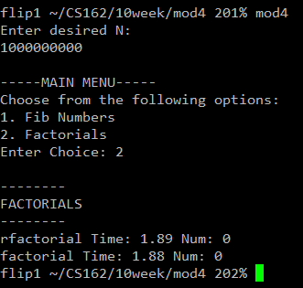

With the factorials, it looks pretty much like I expected. If you use 500,000,000 it will show almost no difference. As it gets closer to 1,000,000,000 it will start to increase. I would assume that the only way to see significant differences in this is to have a number so large that you will forget what digit you are on when typing it.

All-in-all, this turned out as expected. I knew that the recursive functions would take longer, but honestly if you are using the factorial stuff in real life, you wouldn’t need to worry about it unless you were using a massive number of recursions. On the Fib numbers however, this shows up VERY soon and would be a horrible efficiency level. Your software would be turtle slow and people would not want to use it.